LAGUNA FOLK DANCE FESTIVAL – 50 YEARS YOUNG!
The next Laguna Folk Dance Festival will be held March 6-8, 2020 and it will be the 50th anniversary, so this festival will be a doozy! Legendary YVES MOREAU (who taught at our 25th Festival and will be teaching mostly Bulgarian dances, as usual) is already confirmed as one of the main teachers, as is young and energetic AARON ALPERT who will be teaching Israeli dances. There will also be CAMEO appearances by former Laguna Festival teachers TOM BOZIGIAN and LEE OTTERHOLT. And the National Folk Organization (NFO) will be holding its annual conference in conjunction with the festival, so many dance leaders from all over the United States will be there.
The Festival will, as always, include dancing to LIVE MUSIC (three bands!) Friday night, workshops all day Saturday, a very happy Happy Hour (with dancing to 50’s style pop and rock music!) and a gala dinner that evening followed by dancing to live music with MIAMON MILLER and band, then reviews Sunday morning, a concert after lunch (catered meals are available onsite both Saturday and Sunday so you don’t have to leave the beautiful clubhouse where we dance), and again dancing to live music Sunday afternoon.
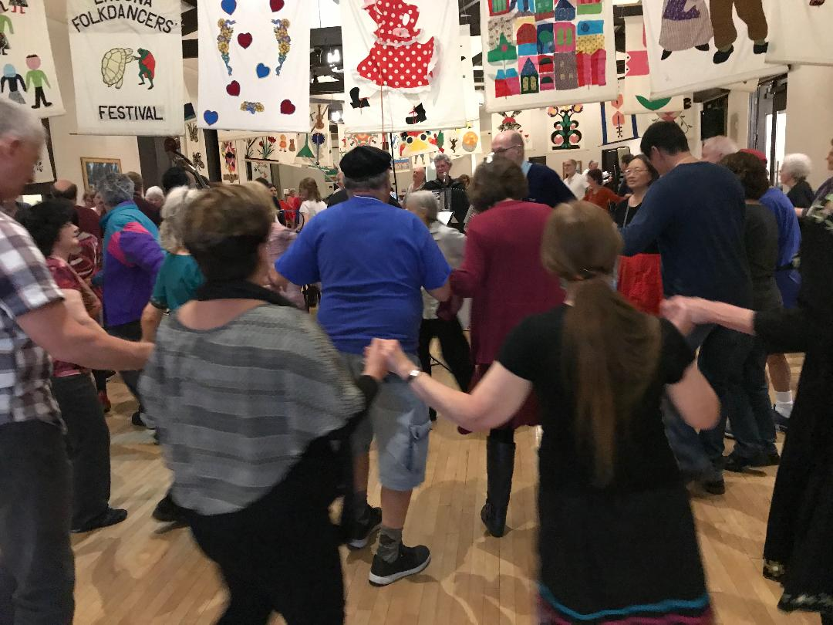
Also, as always, our popular SING-ALONGS will be led by the always-cheerful MICHAEL LAWSON and the Southern California Lifetime Achievement Award will, for the 5th time, be awarded to a worthy recipient who has made an exceptional contribution to the Southern California folk dance scene.
If you are coming from out of town, you can book rooms at the nearby Ayres Hotel at a discounted rate. The Ayres Hotel is a short walking distance from the festival venue.
In honor of our 50th anniversary every participant will also receive a charming, complimentary souvenir of the event to remember this certainly very memorable event by.
And, if you can stay an extra day, we will DANCE ON THE BEACH on the Monday after the festival – a very unique experience not many other festivals can offer!
Registration for the festival is now open at www.lagunainternationaldancers.com You can now register and pay online, or you can download a form and send it in with your check. Do it early, because space will be limited for this very special event!

